The Group was formed in 2007 by a small number of residents interested in promoting, preserving and researching the history and heritage of South Wingfield Parish.

Our annual programme of monthly meetings features illustrated talks by invited guest speakers on a range of local historical topics. Following the speaker, refreshments are served and members take the opportunity to chat. We organise summer visits and guided tours to places of interest. A most enjoyable Christmas meal is held in December.

The group is actively involved in local projects. We championed the preservation of Wingfield Station, successfully lobbying Historic England to upgrade its designation to Grade II*. This relisting was vital in the battle to save the station.

If you have an interest in history or just want to pop along to an occasional meeting and see what we do - you will be very welcome. We are a small friendly group with 28 members.

Membership is £15.00 per year with renewals due in November. Meetings are free to members. Visitors are requested to pay £3 at each meeting.

Member of the British Association for Local History.

For further information, please contact:
carolbrown05@btinternet.com

South Wingfield Local
History Group
Programme
2024

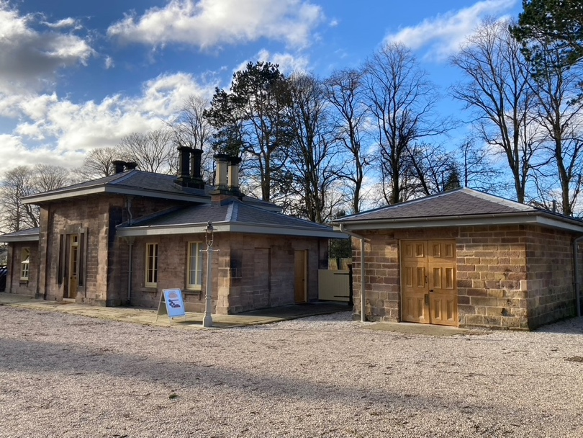

Meetings are held on the second Wednesday of each month (except August) starting at 7.30pm. We meet in the Zion Methodist Church, Manor Road, South Wingfield, DE55 7NH.
A warm welcome is extended to visitors and new members.

10th January Speaker: Frank Bagshaw
‘The National Tramway Museum,’ Crich.
Frank will explain the history and development of the museum as well as touching on the history of some of the trams and exhibits. He is a long-standing volunteer at the museum and will offer an interesting insight into this popular attraction.

14th February Speaker: Steve Hill
‘Everything but cotton: the industrialisation of Ambergate’.
Discover the development of Ambergate’s transport links and range of local industries and the contribution it has made to Derwent Valley Mills World Heritage Site.

13th March Members’ Evening
‘Our holidays’
Come along and share a story of your holidays or a day out from years gone by. In the days when you packed a map and thermos flask. Did you experience the delights of a seaside holiday? Do you remember travel by coach or train and the excitement of your first aeroplane flight? Please bring along a photo or possession to share.

10th April Speaker: Ian Hooker
‘Aqueduct Cottage’
The history and restoration of the cottage from a ruin, including the story of how the cottage came into hands of Derbyshire Wildlife Trust. Ian has been involved with the restoration of the cottage since the outset of the project and remains a member of the group of volunteers that work each week on the cottage.

8th May Speaker: Sonia Preece
‘Old Costumes from the bygone days at Hardwick Hall’
Sonia (National Trust, Hardwick Hall) will bring replica Elizabethan costumes for us to see and talk about their design and fashion. A fascinating insight into the attire of gentry and servants.

12th June Evening Visit Wingfield Station

10th July Visit tbc

August No meeting

11th September Speaker: Richard Godley
‘Britain’s Forgotten Army and Lumberjills’
Richard will share the vital work of the Women’s Land Army during World War Two and explain the role of the Lumberjills.

9th October Speaker: Jeff Bates
‘Derbyshire Historic Gardens’
Jeff has been a professional horticulturalist for over 50 years. He has worked in landscape design & construction and was senior lecturer at Derbyshire College. He will take us on an illustrated tour of some of Derbyshire’s best gardens.

13th November AGM & local guest speaker

4th/11th December tbc. Festive social event – date tbc

